Marking in My.SUPA

Grader Report is the tool that My.SUPA uses to manage the grades from all the SUPA courses. Within your course, it takes the grades from individual activities and lets you aggregate them to suit your grading scheme to generate a final score out of 100 for each student.
You can also use the Grader Report if you need to override any marks that have been generated automatically by assignments and quizzes.

There are three main methods to upload marks, choose the one that most closely fits with your course and requirements:
- Setting course totals for each student manually, useful for single assessment courses with a handful of students
- Calculating course total from multiple activities, useful for continuous assessment for a handful of students
- Uploading grading workbook, useful for large classes or classes with written feedback

If you require any support using Grader Report, please contact SUPA at admin@supa.ac.uk.

Accessing Grader Report
To access Grader Report as a lecturer, go to your course page.
Click the button at top left to reveal the left hand menu. Then use the menu link marked ‘Grades’ (1 in the image below). This will take you to the main Grader Report view. Students will see a similar link to ‘Grades’, but it will only display their own results.

You can either set the total mark and feedback for each student directly, or use a calculation to give marks to a number of activities and calculate the total.

Method 1: Setting the Course totals directly for each student
- Open the ‘Grader report’ (1).
- On the grade view click ‘turn editing on’ (2) button at the top right.
- The ‘course total’ is on the far right. You may use the +/- icon (3) to show or hide individual activity columns to simplify the report.
- In this example the other activities have been hidden and details are only being entered in the ‘Course total’ column.
- For each student, enter the grades as a mark out of 100 in the first box (4). If required, notes or feedback can be provided in the dashed box. This is usually only used for individual assignments.
- Remember to click ‘Save changes’ (5)!
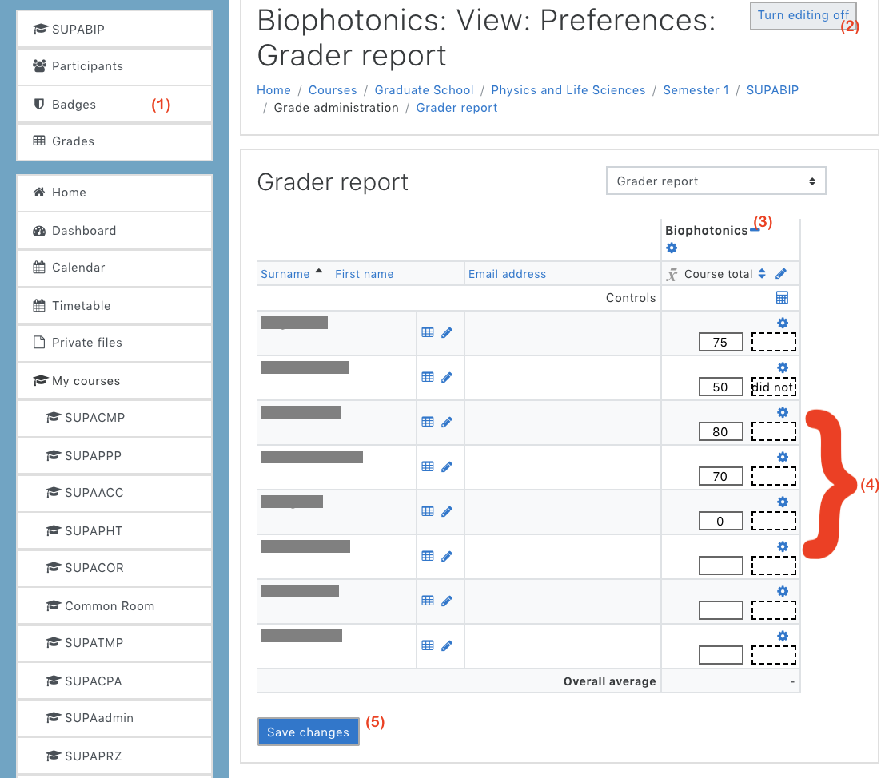
(1)

Method 2: Calculating Marks using calculation from several activities

Some courses are set up to allow you to assign marks to individual activities such as assignments or quizzes.

The grade settings that you use when you set up each assignment or quiz activity in your course will add an additional column into the Grader Report.

To calculate marks, follow the instructions below. More detailed instructions, with photos, can be found at: https://my.supa.ac.uk/mod/wiki/view.php?id=17039

- Enter the Grader Report of your course area.
- Turn ‘turn editing on’ (2)
- Unfold the report +/- icon to show all columns (3)
- Click on the ‘Edit Calculations’ calculator icon at top of the ‘Total grade’ column.
- Assign each assessment an ID number , and tell Grader Report the formula to use to produce a total out of 100.00 (for example if you want to give different weighting to different assessments). Click Save Changes to return back to the Grader Report.
- Enter marks into the left-hand box for each assignment.
- Type any feedback comments into the right-hand boxes with dashed borders.
- Click on ‘Save changes’. The course totals will be generated, and a pass/fail status will be shown on the administration master list.
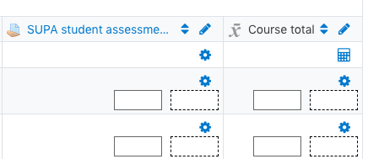
Grade
Feedback

Method 3: Uploading grading worksheet

To quickly enter grades and feedback for an assignment, My.SUPA has the ability to enter marks for all students in one upload.
- Enter the Grader Report of your course area.
- Turn ‘turn editing on’
- Unfold the report +/- icon to show all columns/assignments
- Click on the assignment you want to enter marks for, to take you to the Grading summary for that assignment
- Click “View all submissions”
- At the top of the list of students, choose the “Download grading worksheet” grading action
- The grading worksheet will automatically download
- Open the grading worksheet, and enter the marks and any feedback for any student, for that assignment
- Once all marks are entered, select the grading action “Upload grading worksheet” as above
- My.SUPA will automatically input the marks and feedback from your file

