

**SCHOOL OF ENGINEERING & PHYSICAL SCIENCES**

**Electrical, Electronic and Computer Engineering**

B30ES

Industrial Power Systems

Semester 2 – 2020/21

**April/May 2021**

**Duration: 2 hours**

**Instructions to Candidates:**

Attempt **THREE** questions

It is important to explain your working fully as credit is given for method as well as numerical accuracy.

**Additional Information**

Exam Data Booklet- Supplied

Approved Calculators may be used.

(a) A three-phase, 50 Hz, star connected synchronous generator has 24 stator slots and is wound with two-layer winding. Each full-pitch coil has 10 turns. This synchronous generator is driven at 1500 RPM (revolutions per minute). The sinusoidally distributed flux per pole is 0.02 Wb. Calculate the value of the induced electromotive force (e.m.f) between the lines. (10 Marks)

1. An 11 kV, 1000 kVA, three-phase, 50 Hz star connected synchronous generator has armature resistance of 2 Ω per phase. The open circuit and full-load zero power factor test results are given in the table.

|  |  |  |  |  |  |
| --- | --- | --- | --- | --- | --- |
| Field current (Ampere) | 40 | 50 | 110 | 140 | 180 |
| Open Circuit Voltage (line value in Volts) | 5800 | 7000 | 12500 | 13750 | 15000 |
| Zero power factor, full-load line voltage in Volts | 0 | 1500 | 8500 | 10500 | 12200 |

(i) Construct Potier Triangle graphically and find the field current required to overcome the armature reaction (6 marks)

(ii) From the graph, estimate the armature leakage reactance per phase

(1 mark)

(iii) Find the voltage regulation for full-load, 0.8 power factor lagging by Potier method. (8 marks)

(a) A three-phase, 50 Hz star connected synchronous generator has synchronous impedance of (0+j3) Ω per phase.

(i) If it is delivering active power of 20 MW and a reactive power of 8 MVAR to an infinite bus at 11 kV, determine the load angle and the excitation electromotive force (emf) of the synchronous generator. (6 marks)

(ii) If the field excitation of the synchronous generator is now increased by 20% (without changing the primemover power), find the stator current, power factor and the reactive power supplied by the generator. (7 marks)

(iii) With the field current in part (i), the primemover power is slowly increased. What is the steady-state stability limit? What are the corresponding values of armature current, power factor and the reactive power at maximum power transfer condition? (7 marks)

(b) An industrial three-phase load of 200 kW is supplied at 11 kV, 50 Hz, 0.8 power factor lagging. A three-phase, synchronous motor is required to meet an additional load of 50 kW and at the same time to raise the power factor to 0.9 lagging. Find the kVA capacity of the synchronous motor and the power factor at which it must operate. (5 marks)

(a) What do you understand by the terms normal excitation, under-excitation and over excitation in connection with the operation of three-phase synchronous motor (5 marks)

(b) The data for the three-phase, 50 Hz power system is shown in Figure(3-b):

Generator-1 (G1): 120 kVA, 11 kV and having positive sequence $(X_{1})$, negative sequence $(X_{2})$ and zero-sequence ${(Z}_{g0})$ reactances of 8%,8% and 4% respectively. The neutral is grounded through a reactor of $\left(Z_{n}\right)$ =1%.

Transformers: Two identical 120 kVA, 11/132 kV, delta-star (with star grounded) units T1 and T2 having $X_{1}=X_{2}=X_{0}=$ 3%.

132 kV Transmission Line: $X_{1}=X_{2}=$ 15% and zero-sequence reactance $X_{0}=$ 10%.

Generator-2 (G2): 120 kVA, 11 kV and having positive sequence $(X_{1})$, negative sequence $(X_{2})$ and zero-sequence ${(Z}_{g0})$ reactances of 8%,8% and 4% respectively. The star point is solidly grounded.

Draw the per-unit positive, negative, and zero-sequence networks for this system and then find the amplitude of the fault current when a single line to ground fault develops at 132 kV terminals of the transformer-2 (T2) at substation B. Use a base-quantities of 120 kVA and 11 kV at generator (G1).

**A B**

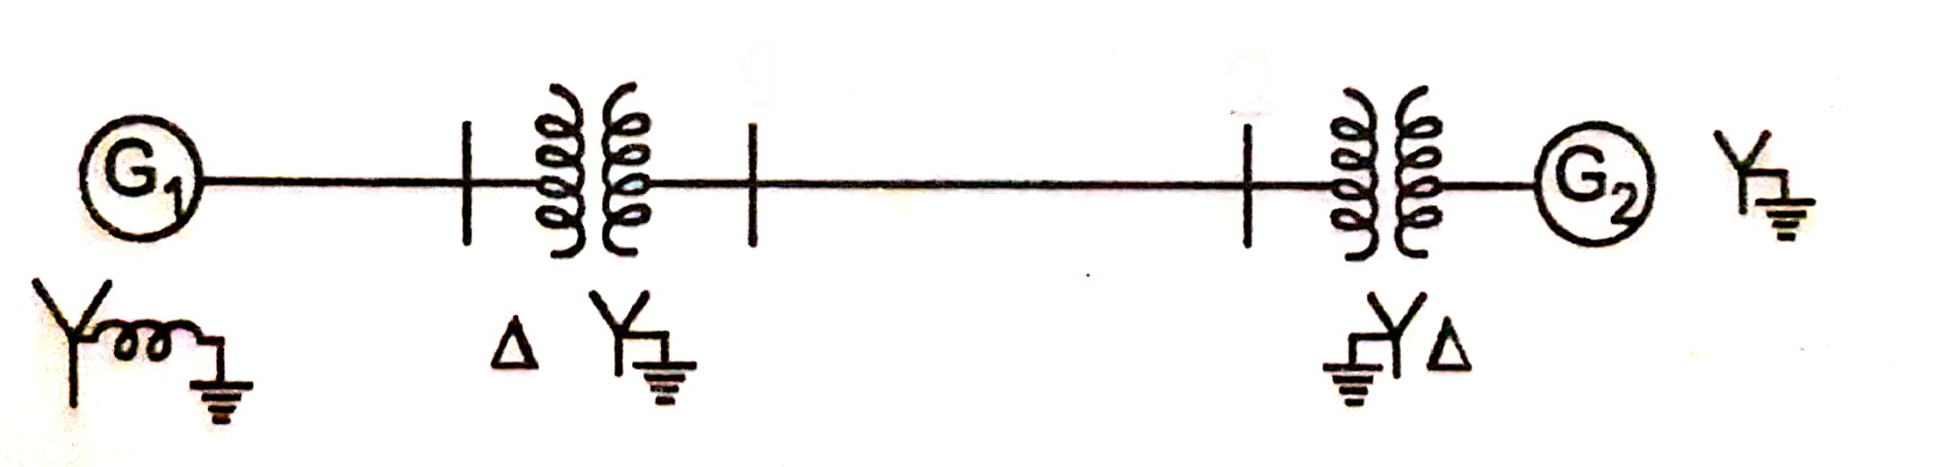

**T2**

**T1**

**Figure (3-b)**

(20 marks)

1. (a) The results of a slip-test on a three-phase, 50 Hz, star connected, salient pole synchronous generator is given below:

The voltmeter connected across the line terminals gave minimum and maximum readings of 96 V and 100 V respectively. The line current fluctuates between 10 A and 7 A respectively.

1. Find the direct axis (d-axis) and quadrature axis (q-axis) synchronous reactances per phase. Neglect armature resistance.

(4 marks)

1. If this synchronous generator supplies a current of 10 A having a phase angle of 25o lagging at 500 V (phase voltage), find load angle ( $δ)$ and the value of direct-axis armature current per phase.

(5 marks)

(b) A three-phase star connected alternator is protected by Merz-Price balance current system. A high resistance earth fault has occurred nearer the grounded neutral end of the generator stator winding while the generator is carrying load. The current flowing at each end of the generator winding under this fault condition are (304+j0) A and (320+j0) A as shown in Figure (4-a). The Current Transformer (CT) ratio is 400/5 A. The relay is set to operate if the out of balance current is above 0.1 A. With suitable calculations find whether the relay will trip the generator circuit breaker under this fault condition? (7 Marks)

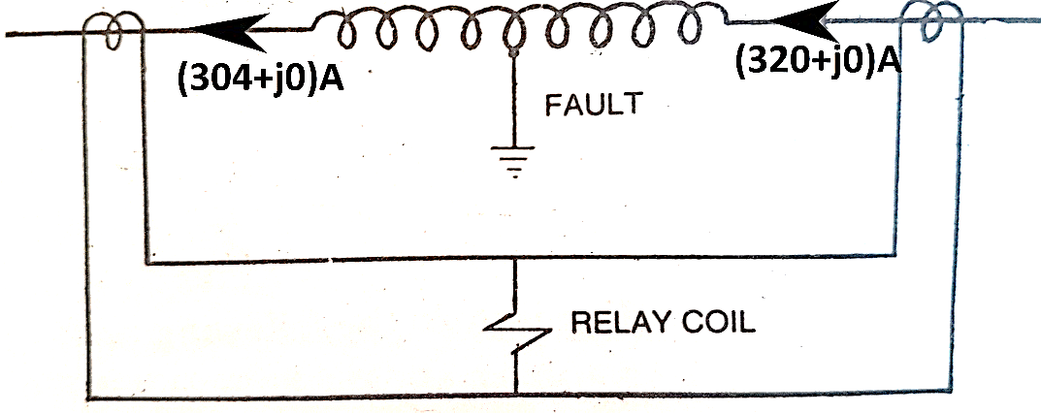

**Figure (4-a)**

1. The calculated short circuit current through feeder line is 1200 A. An over-current relay of rating 5 A is connected for the protection of the three-phase feeder line through a 1000/5 A current transformer (CT). Calculate the operating time of the relay when it has a plug setting of 50% and time setting of 0.8. The characteristic of the relay is as follows:

|  |  |  |  |  |  |  |
| --- | --- | --- | --- | --- | --- | --- |
| Plug setting multiplier (PSM) | 1.3 | 2 | 4 | 6 | 10 | 20 |
| Time in seconds for unity time multiplier setting | 30 | 10 | 6.5 | 3.5 | 3 | 2.2 |

(9 marks)

**END OF PAPER**